|  |
| --- |
|  |
| Capstone Project Document |

**FIRST AID**

Report #6 – Installation Guide

|  |  |  |
| --- | --- | --- |
| **FIRST AID** | | |
| **Group Members** | Đàm Huy Hùng | SE02585 |
| Nguyễn Duy Anh | 01525 |
| Mai Trung Kiên | SE02994 |
| Nguyễn Tiến Dũng | SE03272 |
| Nguyễn Phúc An | SE03118 |
| **Supervisor** | Mr. Nguyễn Văn Sang | |
| **Project code** | FAVN | |

**- Hanoi, 12/2016 -**

# SIGNATURE PAGE

AUTHOR: Nguyễn Tiến Dũng 08/12/2016

Team member

REVIEWERS: Đàm Huy Hùng 09/12/2016

Project manager

APPROVAL: Nguyễn Văn Sang --/--/--16

Supervisor

Record of change

*A - Added M - Modified D – Deleted

|  |  |  |  |  |  |
| --- | --- | --- | --- | --- | --- |
| Effective Date | Changed Item | A,M,D | Change Description | Reason for Change | Rev. Number |
| 08/Dec/2016 | User installation | A | Add new |  | 1.0 |
|  |  |  |  |  |  |
|  |  |  |  |  |  |
|  |  |  |  |  |  |

Table Contents

SIGNATURE PAGE

1. Introduction 5

1.1. Purpose 5

1.2. Environment 5

2. Installation Guideline 5

2.1. Install First Aid Application 5

2.2. Install Ambulance Application 8

2.3. Install Dispatcher Application 10

2.3.1. Setup environment 10

2.3.2. Install application 11

2.3.3. Database configuration 12

2.4. Install Admin/Expert Application 14

2.4.1. Setup environment 14

2.4.2. Install application 14

2.4.3. Database configuration 14

## Introduction

### Purpose

This document contains guidelines step by step to deploy FAVN system. This user's manual has been developed to help users better understand the requirements that may apply to use this system by providing them simple step by step tutorials. This manual is intended to help make system's functions more accessible and their associated requirements more understandable to users.

### Environment

* Following are the software required to start the First Aid system:
* For First Aid Application and Ambulance Application:
* **Operating System:** Android 5.0 or higher.
* **Database**: SQLite
* For Dispatcher Application and Admin/Expert Application:
* **Operating System:** Windows 7, Windows 8, Windows 10
* **Browsers:** Cốc cốc 40, Chrome 44 or higher

**Database:** MySQL

## Installation Guideline

### Install First Aid Application

Step 1: Go to web browser on smart phone (ex: Chrome)

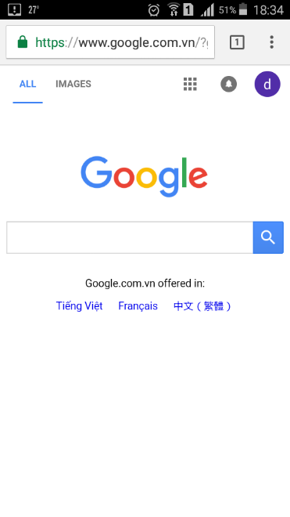

Figure 2‑1: First Aid step 1

Step 2: Go to url: <https://www.mediafire.com/file/5kt341rkmbg4a8r/FA.apk>

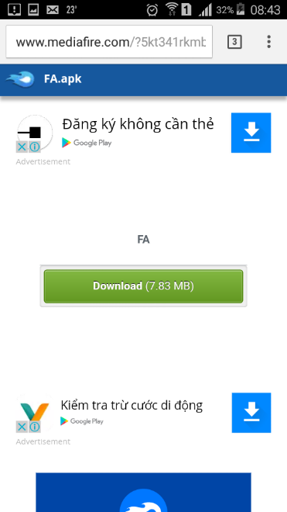

Figure 2‑2: First Aid step 2

Step 3: Tap on Download button to download file FA.apk and run

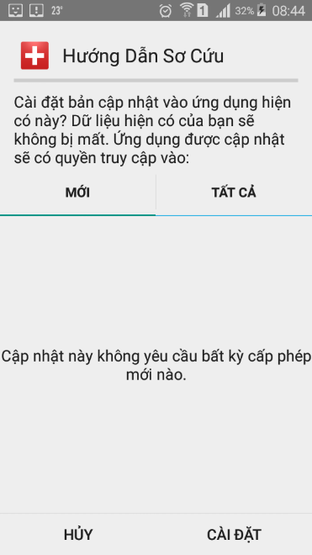

Figure 2‑3: First Aid step 3

Step 4: Finally, tap on First Aid icon to run application



Figure 2‑4: First Aid step 4

### Install Ambulance Application

Step 1: Go to web browser on tablet (ex: Chrome)

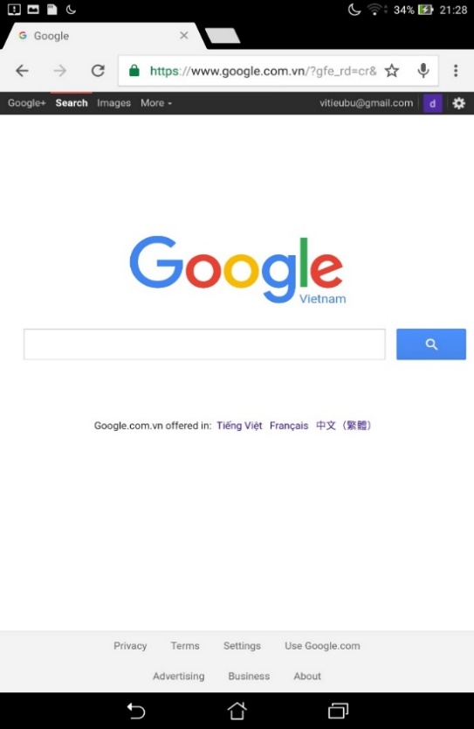

Figure 2‑5: Ambulance step 1

Step 2: Go to url <https://www.mediafire.com/file/ww2jnon8q8j80mj/ambulance.apk>

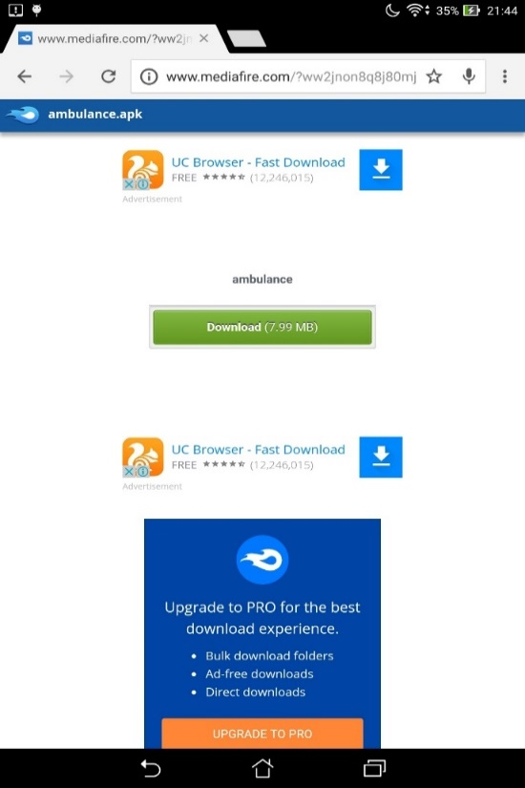

Figure 2‑6: Ambulance step 2

Step 3: Tap on Download button to download file ambulance.apk and run

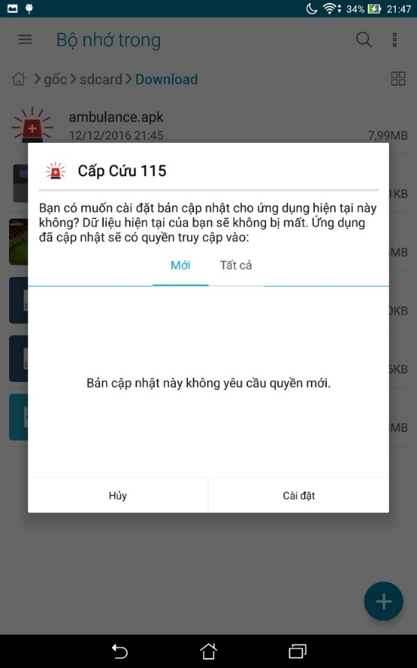

Figure 2‑7: Ambulance step 3

Step 4: Finally, tap on Ambulance icon to run application

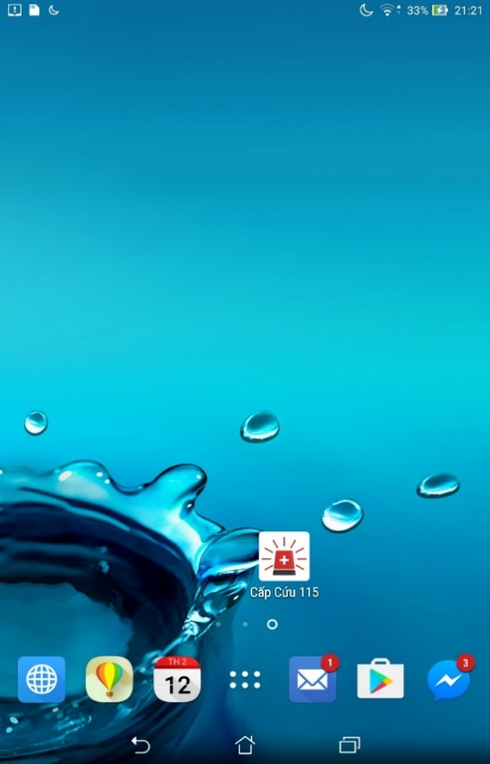

Figure 2‑8: Ambulance step 4

### Install Dispatcher Application

In this guideline we install dispatcher Laravel application on Ubuntu 16.04.

#### Setup environment

* Step 1: Install PHP 5.6

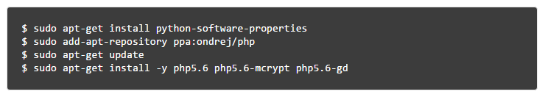

* Step 2: Install Apache2



* Step 3: Install MySQL



* Step 4: Install phpMyAdmin

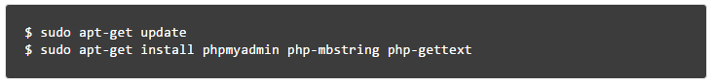

* Step 5: Install Composer

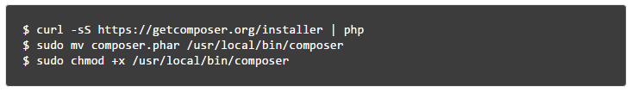

#### Install application

* Step 1: Clone source code from github directory

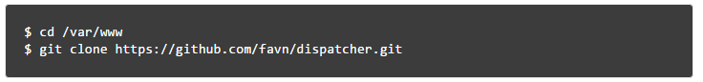

* Step 2: Use composer to install all dependencies required for Laravel framework.

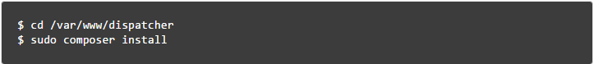

* Step 3: Set proper permissions on files.

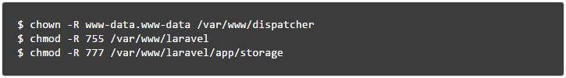

* Step 4: Create Apache VirtualHost



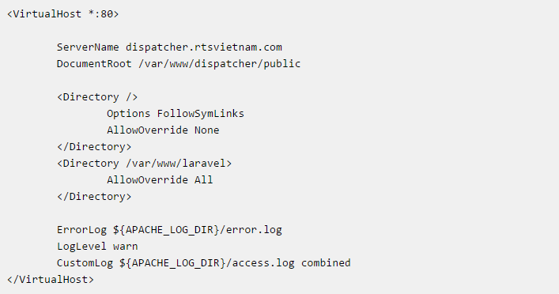

#### Database configuration

* Step1 : Create FAVN database

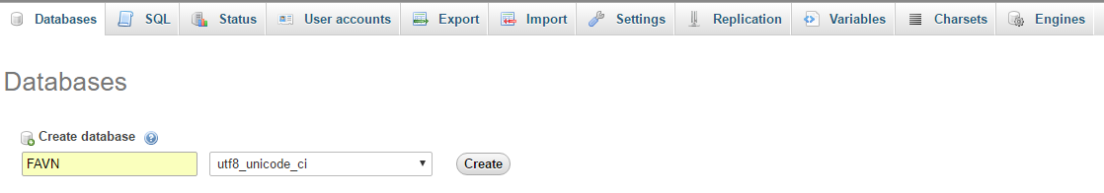

* Step 2: Import FAVN database

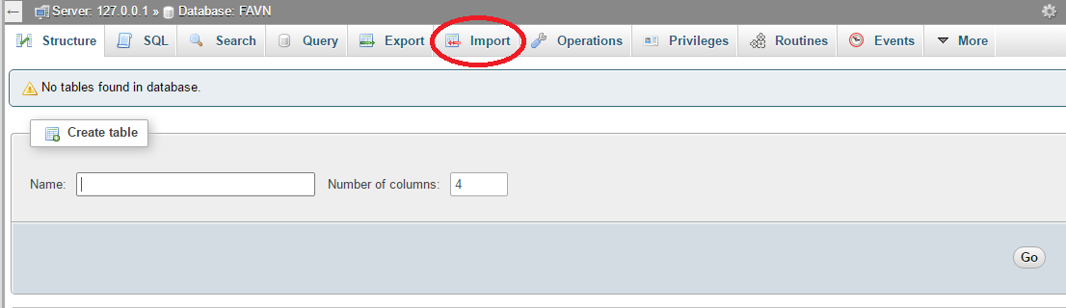

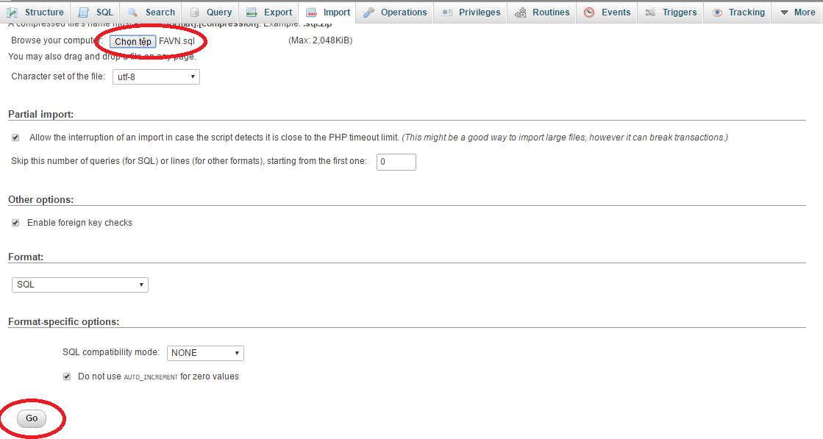

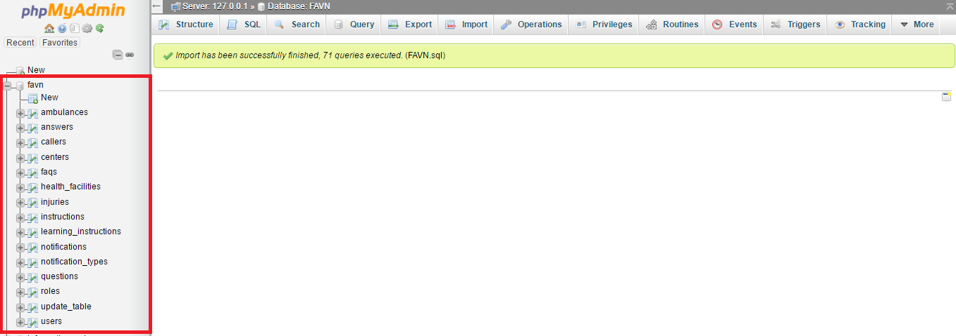

* Step 3: Setting .EVN file

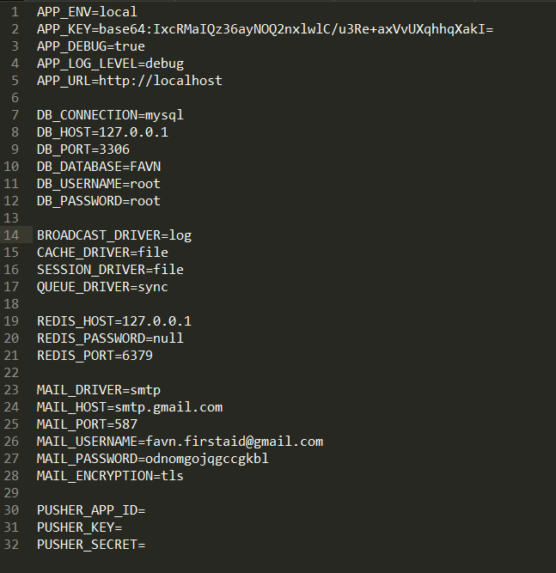

### Install Admin/Expert Application

#### Setup environment

Refer to 2.3.1 of this document.

#### Install application

* Step 1: Clone source code from github directory

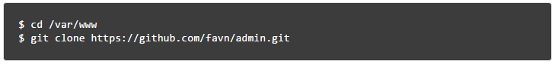

* Step 2: Use composer to install all dependencies required for Laravel framework.

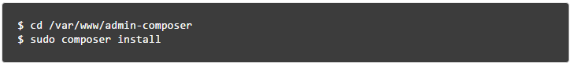

* Step 3: Set proper permissions on files.

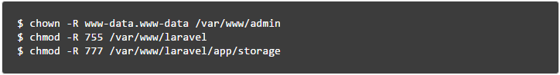

* Step 4: Create Apache VirtualHost



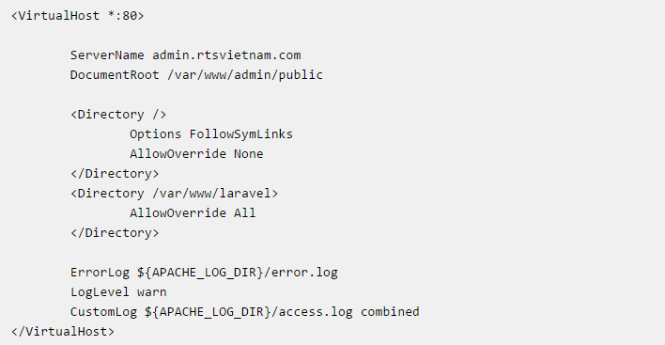

#### Database configuration

Refer to 2.3.3 of this document.